AM000-Lion and Grape Mirrors-Final Final 2015

The Five Lion Dance of Peace and Harmony

**1. The emergence of the Five Lion Dance**

# The Five Lion Dance emerged around 300 CE on the seemingly isolated northern rim of the Taklamakan Desert, now located in Xinjiang Uyghur Autonomous Region. However isolated this region might have appeared, five Buddhist Kingdoms on its north border were inter-connected to that powerful engine of intellectual and economic exchange, the Silk Road, and this made all the difference, for the Five Lion Dance was destined to affect all of China.

**1.2. Geographical Extent**

Between 50 BCE and 1000 CE the Taklamakan Desert was ringed by trails (now known as components of the Silk Road) linking China, Afghanistan, Pakistan, Kashmir and Persia (an area now referred to as Central Asia) to India and Rome.

The northern route around the Taklamakan Desert linked Kashgar, Tumxuq, Kucha, Karaxahr and Turfan. The southern route around the Taklamakan Desert linked Kashgar, Hotan (including Keriya) and a group of six towns: Niya, Qarqan, Qarkilik, Miran Loulan(K) and Loulan (A). When the two routes converged before the Jade Gate in Kansu their next stop was Tun-huang. This was the conduit of Buddhist transmission from India to China.

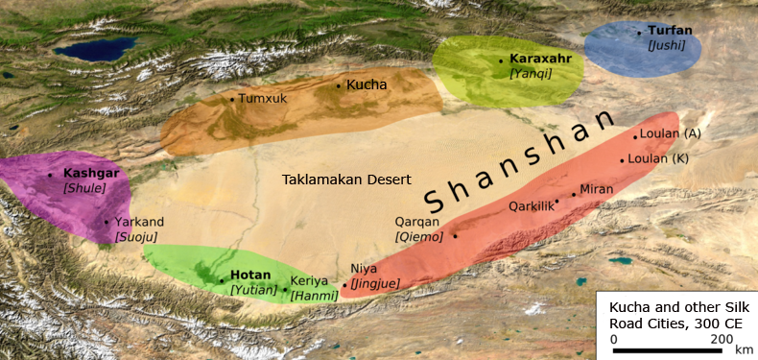

Fig. 1. The five Western Regions kingdoms (Hotan, Kashgar, Kucha, Karaxahr and Turfan) that were to become emblems of Xingjian's hegemony in the Five Lion Dance. Map with modifications after http://upload.wikimedia.org/wikipedia/commons/thumb/d/d0/Tarimbecken_3._Jahrhundert.png/800px-Tarimbecken_3._Jahrhundert.png.

**Linguistic Affiliations**

**Tocharian** (**Tokharian)** is an extinct branch of the Indo-European language family, which was spoken by Tocharian peoples in oases on the northern rim of the Tarim Basin (now part of the Xinjiang Uyghur Autonomous Region of China). Documents dating from the 6th to the 8th century CE/AD record two closely related languages, called Tocharian A ("East Tocharian", *Agnean* or *Turfanian*) and Tocharian B ("West Tocharian" or *Kuchean*). The Tocharian A was preserved in archaic texts and used as a Buddhist liturgical language, while Tocharian B was spoken commonly from Tumshuq in the west to Turfan in the east. Tocharian C (*Kroränian*) is only preserved in Prakrit documents of loanwords and names. These Tocharian languages and their associated Buddhist texts became extinct after Turkic Mongolian tribes expanded into the Tarim Basin in the 9th century CE/AD with their newly adopted religion, Islam, and its holy language, Arabic. *The Qur’an* (القرآن‎‎ *al-Qurʾān,* literally "the recitation") dictated by Allah to Gabriel to Muhammed from 22 December 609 CE to 632, the year of Muhammed’s death at 40 (Shaikh 2001: 50).

When Kucha people created the Five Lion Dance around 300 CE, Tocharian B was spoken in an area extending from Tumxuq in the west to Turfan in the east, a distance of more than 800 miles (Levi 1913, 348-349). It was a golden age of these five Buddhist Kingdoms. But how could a dance involving lions originate in this lonely region of the Taklamakan Desert where no lions had ever existed?The Chinese for “lion**”** *shīzi*, (獅子)derives from the Indo-Iranian *ser*, that connotes *mutual* *protection* *and harmony* symbolized by a powerful, auspicious protector, such as the male "lion", and not from the Indo-European Sanskrit *siṃhá* (सिंह), the zodiacal sign of Leo or its *elevated hero, or sole leader* (Monier Monier-Williams 1898: p. 1213). Therefore, the source of the concept of “lion” came from Persia where Indo-Iranian languages were spoken and the word filtered through Persian traders along the northern Taklamakan route of the Silk Road. The evocation of harmony devolving from mutual protection has not disappeared despite the People's Republic of China's crackdown on ethnic minorities who still preserve this image of a just, civil society based on *mutual* *protection* *and harmony,* since some of the descendants of Kucha are still renowned for their “Five Lion Dance” that symbolizes the five kingdoms (Hotan, Kashgar, Kucha, Karaxahr and Turfan) and is performed regularly at communal ceremonies, a tradition that is at least 2500 years old.

The storm of Turkic Mongolian Muslims spread along the northern rim of the Taklamakan Desert and partially desecrated human visages in Buddhist grottoes, since depictions of eyes whether they be of pilgrims, apsaras or Buddhas were anathema to Islam, which proscribed the making of graven images of the human face as heathen idolatry. Many inhabitants of the five Buddhist Kingdoms fled east along the Silk Road to new homes in China bringing their Five Lion Dance with them. In the midst of this turmoil, the Five Lion Dance evolved from its original intention of promoting peace and harmony among the five Buddhist Kingdoms (ca. 300) to one that promoted peace and harmony for the entire cosmos (ca. 600). In just 300 years the message of the Five Lion Dance had expanded to impact China with its message of communal harmony.

In the period prior to the Islamicization of Xinjiang the Five Lion Dance had evolved in its choreography. In the five Buddhist Kingdom phase of the Five Lion Dance, which is described in the *Tang-ch 'i* chronicle, there are only four dancers specified so that each one presumably occupies one lion outfit. The fifth lion is presumably an actual trained lion from Persia with its handlers. In a later version of the Five Lion Dance two participants manned wicker lion outfits, one fore and one aft. The fifth lion which occupied the central position in the choreographed dance, is also a trained lion, managed by twelve handlers (Harich-Schneider 1973: 166). The use of an actual lion in the central position conveyed the meaning of the Indo-Iranian *ser* as a powerful protector.

The size of the masked lions grew over the next three hundred years so that by the time of the T'ang court at Chang-an (618–907), which was one of the largest cities in the world with ca. 1 million inhabitants, each of the five lion figures was activated by twelve men and each lion outfit was given the color appropriate to one of the classical Chinese five directions, black for north, blue for east, red for south, white for west, and yellow for the center. By invoking the Chinese five directions, the Five Lion Dance had now taken on a Sinitic appearance (*Hsin T'ang-shu*, 21.7), that coincided with the T'ang court’s quest for communal harmony after centuries of war and bloodshed.

Appropriately, T’ang versions of the Five Lion Dance ended with an accompanying peace song. Originally, this was orchestrated, according to the *Tang-ch 'i* chronicle, with "a zither, a harp, a lute, a flute, a mouth organ, [and] several drums” (Harich-Schneider 1973: 166). In the T'ang period the accompanying peace song may be the one quoted in the official history of the Sui dynasty (completed in the T’ang dynasty, 636 CE/AD), *Suí Shū*, 15.14b where all participants were enjoined to sing of a world of peace and harmony and to still the weapons of war.

This is the musical arrangement and choreography of the Five Lion Dance it extolls in its "Ten Thousand Years Song," preserved in a yet later version of the Five Lion Dance as given in the *Yueh-fu tsa-lu* of An-ch'ieh Tuan, fl. 880 CE (Tuan 1985; Gimm 1966) which has been made available in a line-by-line translation by An-ch'ieh Tuan from *Yuefu Miscellany* (http://www.tianyabook.com/gudian/yuefuzalu/index.html):

#### "Order of the Qiuci [Kucha] Ceremony"序龟兹部》

#### 1) The music is arranged with a bamboo horn, a flute, and a four-pitch Jie drum (羯 鼓).

#### 乐有觱篥、笛、伯板、四色鼓、揩羯鼓、鸡楼鼓

#### 2) Five lions play with feet exposed and with colored clothing. 戏有五方狮子，高丈馀， 各衣五色。

#### 3) Each lion has red whiskers and is comprised of 12 people who wear red-colored garments and performs in what is called the "Lion Cub" dance accompanied by the "Peace Music" song. 每一狮子有十二人，戴红抹额，衣画衣，执红拂子，谓之“狮子郎”， 舞《太平乐》曲。

#### See the "Great Peace Music" melodies which accompanied the dance proper and were elevated to the number two standing dance (Picken 1988, 4:32).

#### 4) "Prelude of Dissonant Music." This melody is in the Qin system in which everyone dances in a colored garment. They carry flag pennants; in spring and winter the foreign rival principalities give tribute to the military in dancing this song. Concurrently, the cavalry enters the field, which is particularly spectacular. [This scene shows how the entering Chinese cavalry subdues the dissonant foreign rival principalities. In earlier versions of the dance the five rival principalities were probably portrayed as being in harmony among themselves without an intruding Chinese cavalry contingent.]

#### 《破阵乐》曲亦属此部，秦王所制，舞人皆衣画甲，执旗旆；外藩镇春冬犒军亦舞此曲，兼马军引入场，尤甚壮观也。

#### [In this section we clearly have a Chinese version of the Five Lion Dance with the original Five Buddhist Kingdoms doing homage as vassals to the Chinese cavalry. This is a classic example of the Chinese Han exerting its hegemony over what the Han would have referred to as one of their ethnic minorities.]

#### 5) Then the "Ten Thousand Years Song," which is also known as the Wei song, is also called "Heaven's Immortal Child."《万斯年曲》，是朱崖李太尉进此曲名，即《天仙子》是也。[Celebrating the fact that harmony will last ten thousand years and the Shang-ti is blessing the event as his "child" or progeny.]

**1.3 Iconography of the Five Lion dance**

Based on these various versions of the Five Lion Dance, symbols of several cultural traditions appear to have been silently incorporated.

**1.3.1. Tree of Life.**

The Tree of Life is an ancient Central Asian image among the Mandaeans. The Mandaeans are an indigenous Mesopotamian people who originally spoke Mandaic, a Semitic language, but then switched to Indo-European Persian, while still maintaining Mandaic as their liturgical language (Drower 1962). When the Five Lion Dance was visually transferred to the medium of bronze mirrors, imagery of lush foliage and clusters of grapes evoked the imagery of the Mandaean Tree of Life (Rudolph 1978). This sacred Tree was based on reverence for and management of clean, pure water, which was the source of life. It was a ancient emblem that was developed by another ethnic group, the non-Semitic, and non-Indo-European-speaking Elamites of the 4th millennium BCE, Persia's earliest civilization(Sykes 2003, p. 38). So once again Persia contributed to developing the underpinnings of the Chinese Five Buddhist Kingdoms.

Following their Elamite predecessors in their reverence for water and its management, people of the towns of the Five Buddhist Kingdoms dug qanāts (Persian: قنات‎‎/)کاری): underground channels 30 feet deep and hundreds of miles long into Tien Shan's upper Kyrgyz Mesozoic and Cenozoic sedimentary rocks, rocks that were fairly easily quarried. These channels in turn carried water from glacial catchments high in the Tien Shan mountains to the north to the Five Buddhist Kingdom towns in the south. The qanāt technology, like the cultural idea of the Five Lions Dance, was, again, a product of Persia. The underground water channels were dug on an angle of about 7 degrees in order to carry the flow of water south to the towns. But the flow also carried with it debris that had to be removed periodically. So vertical shafts were spaced at approximately 90-foot intervals to access the underground channels where detritus would accumulate. Consequently, each spring communal workers descended vertical clean-out shafts by means of pulleys and filled their buckets with rock, mud and silt, which were hauled to the surface and dumped around the clean-out shafts. Long lines of these punctured mounds stretch to the horizon like rows of gigantic ant hills. The qanāt system having originated in Persia was successfully transferred to the Five Buddhist Kingdoms which transformed desert towns into Silk Road oases and made them gems of Buddhist culture in the midst of an intractable desert. Today, grape vines in Xinjiang are luxuriant as they emerge from pure qanāt waters, and, although the local populace is probably unaware, these vines evoke the Mandaean paradisiacal Trees of Life.

However, when the towns were inhabited by peoples of the Five Buddhist Kingdoms prior to the Turkic Mongolian invasion it was well-known that the grape vines growing from the pure qanāt waters were analogous to the vines of the Mandaean paradisiacal trees as they were depicted in the Sangim Grotto frescoes. Indeed, the emergence of the Tree from water was considered a sacred marriage emblem: in Mandaeaism the male date palm (Mandaean *sindirka*) is the Tree of Life which depends on the waters of the well (Mandaean *'aina*) the female principle to complete the "sacred marriage." Out of this union of the tree and water, Mandaean vine iconography was born. Just as vines interlace the trees, the Buddhist faithful are supported by the cosmic Tree of Life, the Buddha. The continuum of tree and vine is the emblem of true Life (Ryen 2006:203).

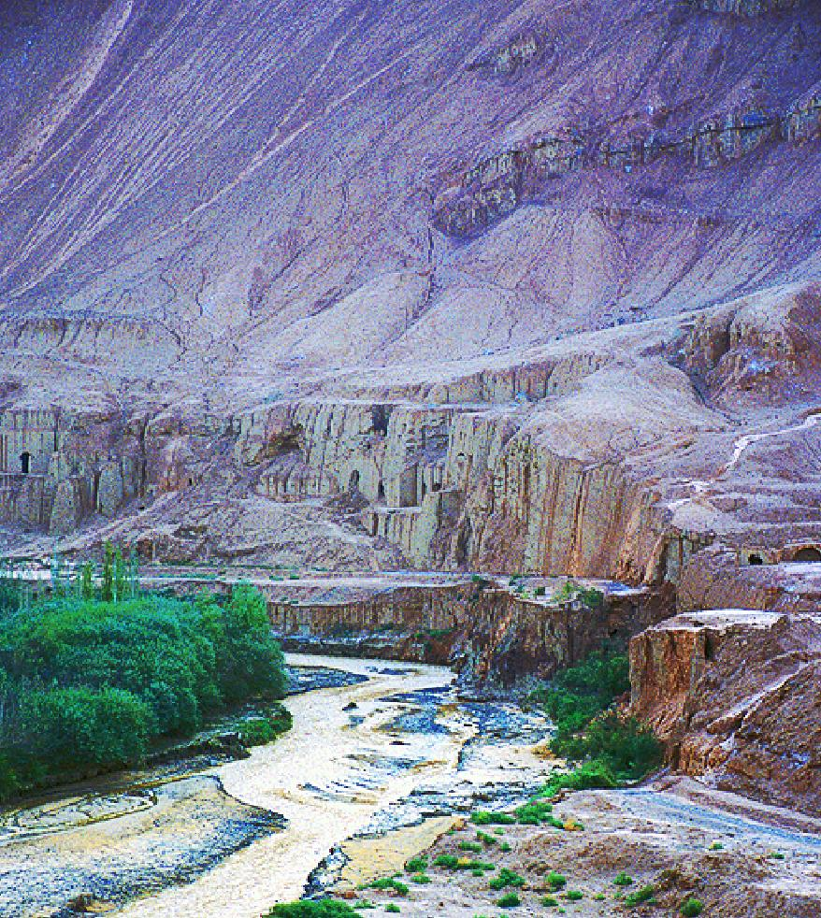

Fig. 2. Sangim Grottos east of Turfan. Photographed by Noboru Ogata (1998)

http://www.hgeo.h.kyoto-u.ac.jp/ogata/turpan1998/shengjinkou_01_e.html

In the frescoes of the Sangim Grottos the leaves of the tree are not green but white, reflecting the source of Life in the Light-world. Furthermore, the grape clusters are thoroughly interlaced in the tree so that they appear to be its fruit. (See Fig. 3) So too are the faithful are interlaced with the teachings of the Buddha, and above the Tree of Life are lotus blossoms, symbols of Buddhist enlightenment.

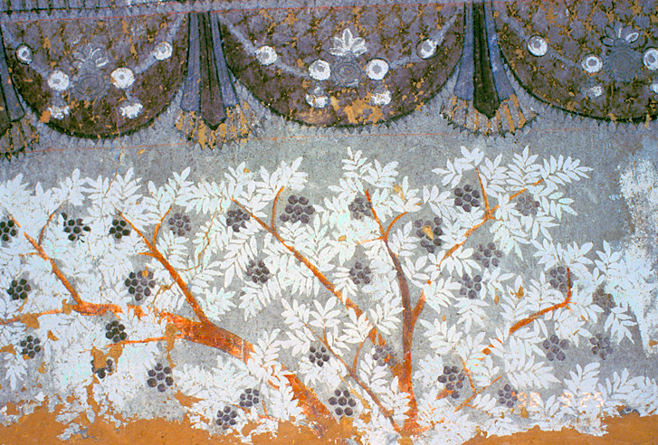

Fig. 3. The Tree of Life inside the Manichaean Temple of Sangim Grottos east of Turfan with entwining vines and with Buddhist lotus blossoms pendant above. Photographed by Noboru Ogata (1998). http://www.hgeo.h.kyoto-u.ac.jp/ogata/turpan1998/shengjinkou-cave_01_e.html

**1.3.2. Tree of Death.**

However, in Manichaean dualism a Tree of Death stands in opposition to the Tree of Life, reflecting the Persian influence that affirms the existence of evil and destructive forces. The white tree (Tree of Life) and the black tree (Tree of Death) symbolize the Gnostic dualism of good and evil at the heart of Mani's doctrine. The dualism of a white and a dark tree in this fresco in the Sangim Grottoes suggests a balance of Buddhism and Manichaean dualism. It reminds us that the Buddhism of the Five Kingdoms was a complex, syncretistic product of the Silk Road, the product of a knowledge conduit where disparate ideas, ideas that were seemingly at odds, could be left unencumbered to generate new concepts without being ostracized. This suggests that the Kingdom of the Five Buddhas wa free to incorporate new ideas and free to enhance and refine old ones however disparate they may appear at first.

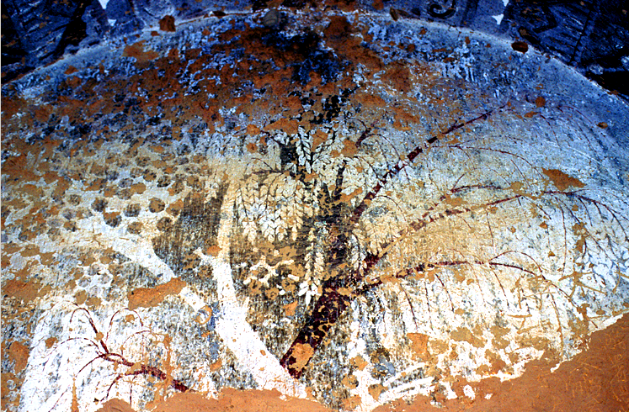

Fig.4. The Tree of Death inside the Manichaean Temple in the Sangim Grottos east of Turfan. Photographed by Noboru Ogata (1998). http://www.hgeo.h.kyoto-u.ac.jp/ogata/turpan1998/shengjinkou-cave_02_e.html

**1.3.3. The Four SacredTrees of Buddhism**

Tree iconography has other Buddhist aspects that encouraged a young Buddhist monk, Xuanzang (玄奘, ca. 602–664) in the early T’ang dynasty to pursue Buddhist texts in India where Siddhartha Gautama, the Buddha, in the 5th century BCE used to sit in meditation under four trees: the Bodhi, the Nigrodho (*Ficus indica*), the Machalindo (*Stravadia*) and Rajatana (*Buchania latifolia*) all of which are deemed sacred.

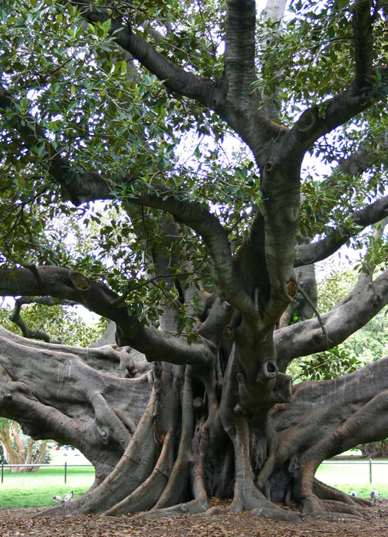

Fig. 6. Nigrodho known as the "everlasting fig tree" from https://thinkhebrew.files.wordpress.com/2009/12/fig_tree21.jpg

The Nigrodho was known as the "everlasting fig tree" that grew from a mound at Prayaga (Sanskrit, *Po-lo-ye-kia*) at the confluence of the Ganges and the Yarmuna rivers now in the Allahabad military fort. This archetypal tree mythically marked the cosmogonic center that separated heaven and earth before creation, before duality, before life and death. There, in 644 CE, Xuanzang recorded how he visited "the great tree with spreading boughs and branches, and casting a deep shadow. There was a body-eating demon here, who, depending on this custom [of committing suicide] made his abode here; accordingly, on the left and right one sees heaps of bones. Hence, when a person comes to this temple, there is everything to persuade him to despise his life and give it up ... . From very early days till now [644 CE] this false custom has been practiced” (Xuanzang 1884, 1-232). Xuanzang felt that the objective of the devoted worshippers who ended their lives at the Nigrodho tree, conceived a false pilgrimage by suicide to return to the point before the duality of life and death was initiated. Their journey to paradise was misplaced as the real paradise was on earth, and death was a spiritual death to the earthly self.

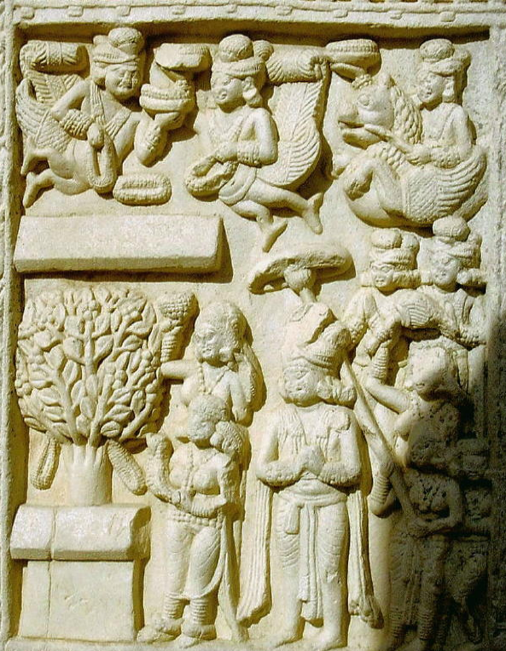

Fig. 7. Sanchi, northern gateway exterior, Madhya Pradesh, India. High stone relief of Buddha as a tree having descended from Tushita (heaven). Photograph after http://personal.carthage.edu/jlochtefeld/buddhism/sanchi/ngextdescent05.jpg November 2005

Tree images of the Buddha on the northern gateway exterior of Sanchi affirm that *life* presents itself as the beginning before the separation of it from death, as Xuanzang felt. This scene represents Buddha as the tree in the lower left having descended from Tushita (heaven). He is attended above by a legion of celestial beings who are throwing flower garlands upon the earth in celebration.  Below, his father and mother, the king and queen, are under a royal umbrella. The queen has her hand raised to grip a tree branch. The event being recorded is Siddhartha's mythic birth from Tushita and also his actual birth, since his mother was reported having delivered him while holding onto a tree branch for support. The umbrella has the significant function of identifying this place (Lumbini) as the center of the earth, since the umbrella represents the cosmos and its handle represents the cosmic pillar.

A second scene at Sanchi depicts the Buddha again as a tree, beneath which two women and a child (?) at the lower left are kneeling with outstreched praying hands.  Two monkeys are approaching the tree, one holding a honey pot, the other holding a torch that is emitting smoke to quell the bees. Siddhartha's father, king Suddhodana Tharu, leader of the Shakya clan in the state of Kosala, India, and his mother, queen Maya Devi Tharu, who look ceremoniously at the monkey procession on their way to acquire honey from a bees’ nest in Buhha’s tree. The honey they are seeking to acquire suggests a metaphoric meaning: the spiritual teaching of Siddhartha. On a literal level, since honey was so precious an offering often endangering the honey seeker, it was a very special gift of these simians to offer, and it also accords with the Buddhist reverence of all beings within the realm of his spirituality. In these depictions of trees, whether as the cosmic center or as the Buddha, we have an iconography that is glorifying the tree as a central mythic object deserving the highest veneration.

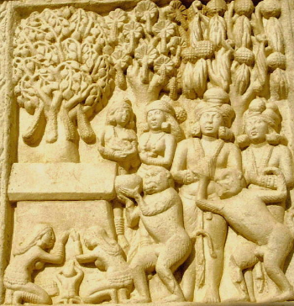

**1.3.4 Iconography of the Vine**

Fig. 8. Sanchi, northern gateway exterior, Madhya Pradesh, India. High stone relief of Buddha as a tree. Photograph after http://personal.carthage.edu/jlochtefeld/buddhism/sanchi/ngextdescent05.jpg November 2005

Among traditions that had a highly developed iconography of the vine are Christianity and Mandaeism in which Jesus (John 15) and his mother Miriai (JB 129,19) are personified respectively as vines and who are simultaneously representative of all believers as well (Ryen 2006: 304-305). However, as we can see in the frescoes in the grottoes of Kucha and Turfan (Bezeklik) there are depictions of vines that are adorned with precious stones, pearls and birds. This iconography appears to be distinctly a Mandaean-derived symbolism and is distinguished by its exuberance from the austerity of Johannine imagery (Percy 1939:234). It appears that this Mandaean imagery was adopted by Manichaeans and added to their religious iconographic repertoire in these grottoes.

Anyone who has stood under the grapevine arbors in Kucha and Turfan cannot help but appreciate this imagery as the sunlight sparkles through the maze of clusters of yellow grapes with their green leafy foliage, that grows as a result of water channeled through the town's irrigation ditches as it emerged from the underground *karez* that bring the waters of the mountains to the people. It is this water imagery, we believe, that is behind the iconography of the tree and the vine in the Five Lion and Grape mirrors.

**1.3.5 Iconography of the Lion**

Since the lion never was in the Western Regions, its origins lie to the west, in the zone of Indo-European Persia where the Sogdian depictions of the lion hunt prove that they were there in the seventh century CE., although Persian lion iconography is entirely different from than that which is displayed on the Five Lion Dance mirrors (Azarpay 1981:172). As we have noted, the Chinese word for "lion" is 獅子 (Shīzi) which was transliterated from the Persian Shir (شیر). The lion was first sent from the western lands as tribute to China from the area of present-day Afghanistan, then known as Wuyi shanli 烏戈山離 or Paite 排特. Wuyi shanli, the terminus of the southern branch of the Silk Road that led from the Western Regions (modern Xinjiang) to Central Asia (Ban 1938). Several instances of lions as imperial tributes from Central Asia were recorded in the document [*Book of the Later Han*](http://en.wikipedia.org/wiki/Book_of_the_Later_Han) (後漢書) written from 25-220. On one particular event, on the eleventh lunar month of 87 CE, "... an envoy from Parthia offered as tribute a lion and an ostrich"(Dili Scroll 4) to the Han court. Indeed the lion was associated by the Han Chinese to earlier venerated creatures of the ancient Chinese, most notably by the monk Huilin (琳说) who stated that "the mythic [suanni](http://en.wikipedia.org/w/index.php?title=Suanni&action=edit&redlink=1) (狻猊) is actually the lion, coming from the Western Regions" (狻猊即狮子也，出西域). suanni is a mytical beast that looks like a lion and said to be one of dragon's nine sons. Due to its desire for smoke, it often appears as a motif for incense burners.

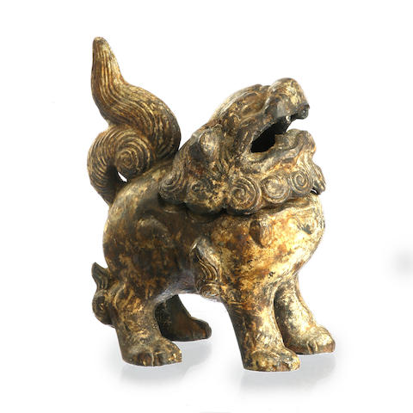

A Chinese cast-iron 'suanni' incense burner from Bonhams. “The mythical beast slightly leaning back, eyes looking up, its head unhinged, *15.1cm high* . Provenance: private collection NSW <https://images1.bonhams.com/image?src=Images/live/2013-05/17/701808-5-1.jpg&width=640&height=480&autosizefit=1>.

The lion’s ferocity earned it such Chinese names as “Heaven’s Blessing” (tianlu 天祿) and “Exorcist of Evil” (bixue 辟邪). In the *Biography of King Mu* 穆天子傳 the lion of the Western Regions is described as resembling the tiger but more ferocious and claimed tigers and panthers as its prey (Shanxiang 1999). The lion was called Suān ní 狻猊, a transliterated word from a dialect in the Western Regions described in the tenth century CE dictionary *Er ya* /爾雅 of Bing Xing (1965) as "a short-haired tiger".

The protective power rather than its ferocity was incorporated into the Dance of the Five Lions mirrors. This aspect of Chinese lion iconography is reflected in stone carvings placed in front of tombs and palace gates or shrine doors, where lions function like guardians, and, like griffins in Western culture, they are often winged.

About the second century CE Buddhism made its way into China from Tibet and India, where an iconography had developed with the lion as a symbol of the Buddha, who was called Shakyasimha, 'the lion among the Shakyas", the clan to which Siddhartha belonged. As early as 208 BCE lions were incorporated in Buddhist monumental art.

In India, the lion played no role in pre-Buddhist religion, but during the Nanda dynasty (about 360 to 324 BCE) lion iconography diffused throughout the empire, which covered nearly the entire Gangetic basin. Travel was secure because the empire was powerful and possessed vast resources (20,000 cavalry, 200,000 infantry and 2,000 four-horsed chariots), so Buddhist pilgrims were freer to travel from grotto to grotto without fear of molestation (Nilakanta Sastri 1952:11-20).

Furthermore, the ancient lion symbolism of Western Asia and Egypt where it had been a dual symbol of the sun and of the king as earthly substitute for the divinity of the sun was not shared by India. However, during the fourth century BCE when the Indra cult was in decline in India, the Nanda and Maurya kings were searching for an emblem of their royalty that had not been co-opted for other purposes. The lion appeared to be a natural choice.

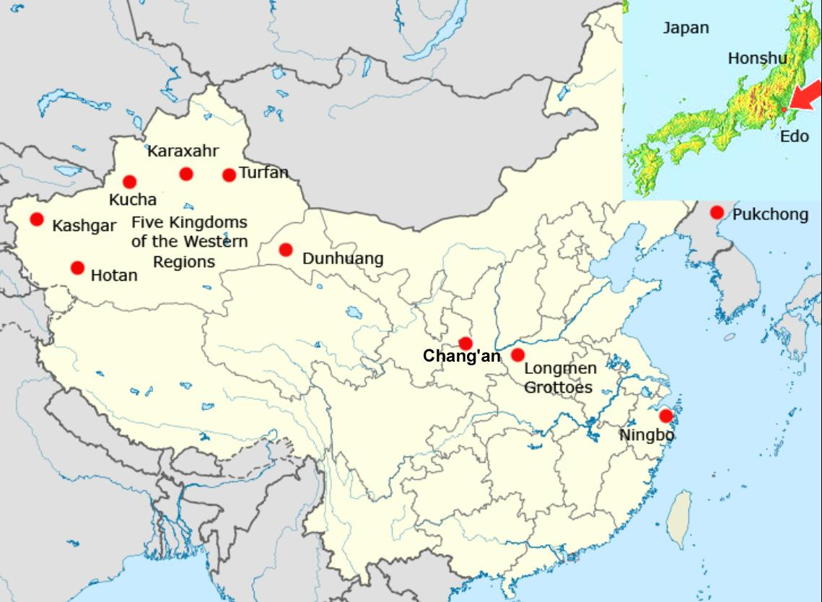

Fig. 9. Map of the diffusion of the Five Lion Dance during the T'ang Dynasty.

**2 The "Great Peace Music" and the Diffusion of the Five Lion Dance**

The "Great Peace Music" melodies that accompanied the dance proper was elevated to the number two standing dance (Picken 1988, 4:32). The "Lion Dance of the Five Regions" was a celebratory ceremonial for continuing peace in the Western Regions. Its popularity was ensured, since the Chinese court was ensconced at its capital in Chang'an from 618 during the T'ang dynasty. Chang'an at this time was the most important cultural center in China being the eastern terminus of the Silk Road, and it was also the most populous city in the world.

Bo Juyi/ Po Chü-i, 白居易 (772–846), a revered poet and responsible civil servant, reflected on the distant origins of the Five Lion Dance as he had seen it performed at Loyang near the Longmen grottoes where he spent his last days compiling his collected works (Waley 1941, 1949):

*Skilled dancers from Xinjiang,*

*Persian masks and lion masks.*

*The heads are carved of wood,*

*The tails are woven with thread.*

*Pupils are flecked with gold*

*And teeth capped with silver.*

*They wave fur costumes*

*And flap their ears*

*As if from across the drifting sands*

*Ten thousand miles away…*

His thoughtful and direct appreciation of the dance reveals the popular appeal that it had and the awareness that it had traveled from the fardistant Western Regions to reach Luòyáng in Hénán / Honan province.

**2.1 The Lion Dance in Korea**

The Pukchong (Bukcheong) Saja-nori lion dance tradition has its roots in Korean shamanism. Although there are several other lion dances as part of Korean mask plays, Pukchong Saja-nori is peculiar in that it is exclusively composed of lion dance, unlike other mask play traditions. Pukchong is a county in eastern South Hamgyong province, North Korea. The tradition had been kept up in the county of Bukcheong -gun, Hamgyungnam-do, in North Korea until the 1930s. At the time of the Korean War in 1950, North Korean performers fled to South Korea in an attempt to preserve the dance, since it was outlawed in the north because shamanism was considered a threat to Communism. It is currently assigned as South Korea's Important Intangible Cultural Property No. 15.

The Korean lion, or "saja," is a costume manipulated by two or three performers. The head of the lion consists of a flat, round, grotesque-looking mask with bells hanging from it. Like its Chinese and Japanese counterparts, it is performed during the lunar new year celebration to fend away evil spirits and beckon good luck.

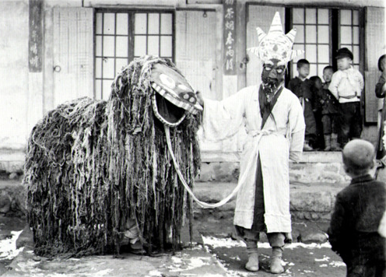

Fig. 10. A Pukchong Korean lion dancer and his accompanist.. From http://25.media.tumblr.com/tumblr_m0o7vqAr041qb2ab9o1_500.jpg

**2.2 The Lion Dance in Japan**

The Japanese lion dance is one of the most popular of *kagura* ceremonies and folk feasts, the *matsuris,* which are performed inside the shrines as well as on stages in the area in front of shrines. The word *shishi* itself means "lion", people do not recall the real animal, but rather the image of the mythical creature. Lions have never lived in Japan, and the cult of the lion, having originated in the Western Regions of what is now Xinjiang Province diffused with Buddhism and reached Japan along the Silk Road along with Buddhist mythology and Chinese T’ang court music and dance, which the Japanese imperial court adopted and adapted.

The Lion dance became part of popular culture and continued into the Edo period. A description of the Lion dance as it was received from Korea was recorded by Aimé Humbert (1874: 300-302) in the early 1870's:

"Perhaps nothing more serious is going on than the dance of the Lion of Corea. How (often everyone [in Edo, central Honshu] has seen it! And nevertheless the discordant appeal of the fife and the tambourine which announce its approach is never resisted. Four actors come out of a neighbouring street; three form the orchestra, and the fourth gives the representation. He is wrapped in a very large striped cloak surmounted by an enormous lion's head. The monster can make himself longer or shorter at will, and suddenly raise himself up two yards above the people who are with him. The children utter cries of mingled admiration and fear. Some, bolder than the rest, venture to lift up the skirts of his cloak, and even to pinch the legs of the mysterious tumbler."

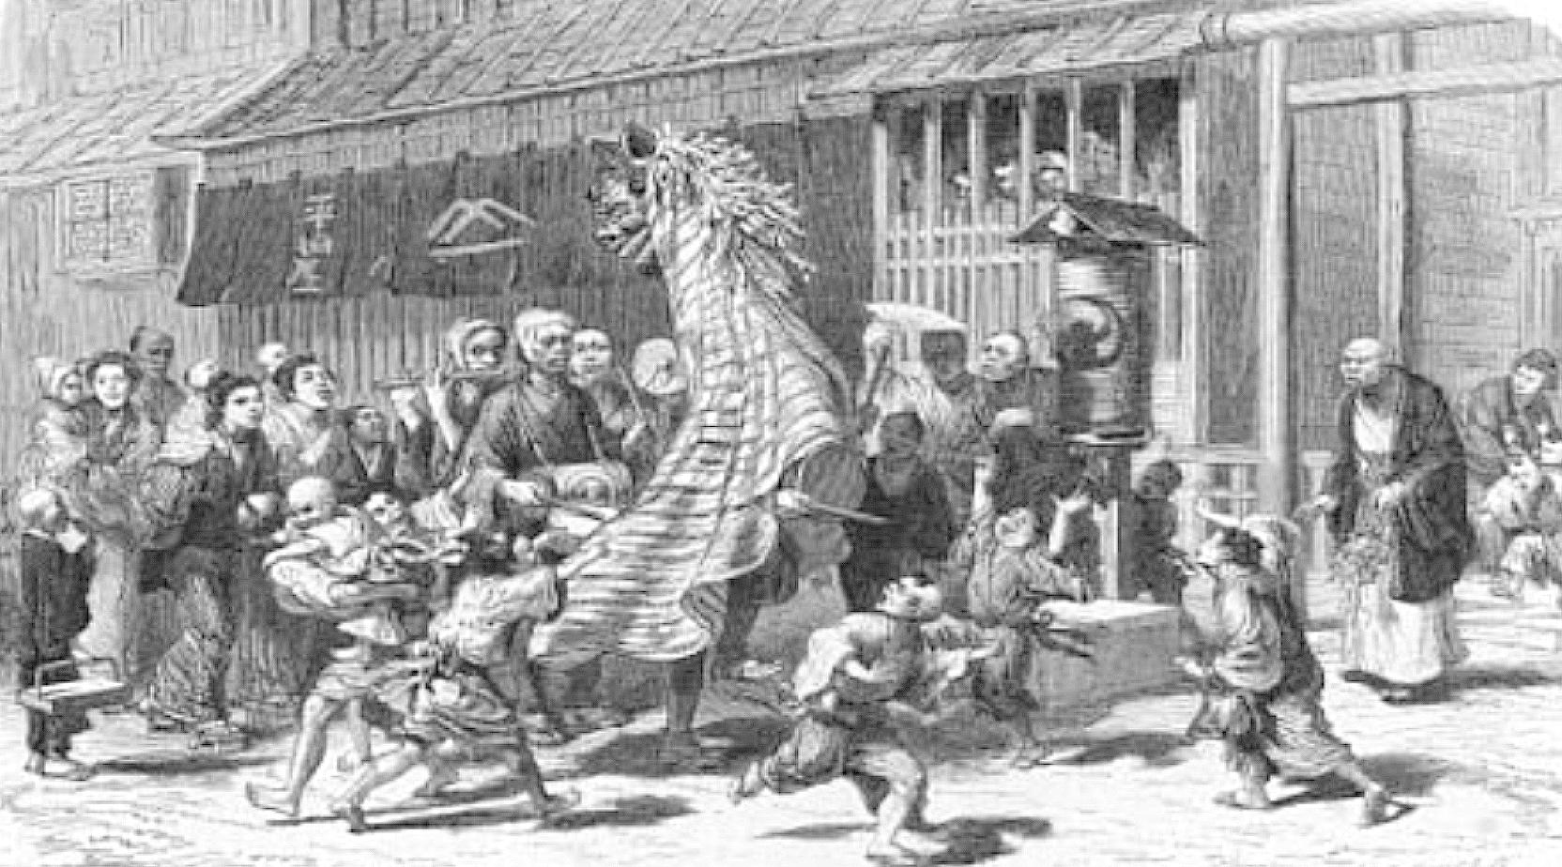

Fig. 11. Japanese children with a street dancer enacting the role of a Korean Lion. Nineteenth century engraving. After http://www.yushodo.co.jp/pinus/59/library%27santiq/pic_m4.html.

"He sometimes frightens them, by turning his head towards them, opening his mouth, and shaking the thick mane of scraps of white paper which surrounds his scarlet face; then he will begin to dance to the sound of the instruments of his companions. He carries his tambourine himself, but as soon as he leaves off dancing he sets it down, and, suddenly stooping, transforms himself into a quadruped, executes some grotesque gambols, and finishes by stripping off his accoutrements. Then the monster vanishes, but the juggler remains. He seizes a drumstick and balances it on the thumb of the left hand; he puts a second stick on the end of the first, and a third crosswise above the other two; finally, he throws them into the air, catches them with his hands, and spins them about more and more rapidly and uninterruptedly, adding one, two, or three balls, which come from no one knows where. The admiration of the spectators is at its height. One of the musicians passes round a plate—that is to say, a fan. The representation is finished, and the juggler lights his pipe from that of some benevolent neighbour. It is not uncommon to see him negligently putting on his costume again, and sitting calmly smoking, with his head covered down to his nose with the enormous and grotesque mask of the monster. The latter is the most picturesque part of the spectacle."

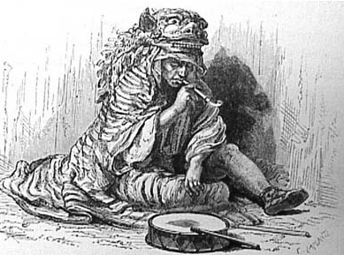

Fig. 12. Japanese Lion dancer after the performance. Nineteenth century engraving. After http://www.yushodo.co.jp/pinus/59/library%27santiq/pic_m4.html

The lion dance was completely absorbed into Japanese tradition and is used even in religious Shinto festivals aside from New Year celebrations. The Japanese lion consists of a wooden, lacquered head called a "shishi-gashira" (lit. "Lion Head"), and a characteristic body of green dyed cloth with white designs. It can be manipulated by a single person, or two people, one who manipulates the head. As with Chinese lions, the head and designs on the body differ from region to region, and even from school to school.

In Okinawa, a similar dance exists, though the lion there is considered to be a legendary *shisa*. *Shisa* (シーサー) (Okinawan: *siisaa*, *shishi* or *shisaa*) is a traditional Ryukyuan decoration, often in pairs, resembling a cross between a lion and a dog which is derived from Okinawan mythology. People place pairs of *shisa* on their rooftops or flanking the gates to their houses. *Shisa* are wards, believed to protect from some evils. When in pairs, the left shisa traditionally has a closed mouth, the right one an open mouth (Chizue 1973). The open mouth wards off evil spirits, and the closed mouth keeps good spirits in.

Its close resemblance in both appearance and name to the Chinese獅子 *shīzi* suggests its Chinese origins, the old Ryūkyū Kingdom (pre-Japanese Okinawa) having very close ties with China. In the 16th century, the sanshin reached the Japanese trading port at Sakai in Osaka, Japan. In mainland Japan, it evolved into the larger shamisen.

The heads, bodies and behavior of the *shisa* in the dance are quite different than the shishi on mainland Japan. Instead of dancing to the sounds of flutes and drums, the Okinawan shisa dance is often performed to folk songs played with the Okinawan musical instrument sanshin ([三線](http://ja.wikipedia.org/wiki/%E4%B8%89%E7%B7%9A), literally "three strings") similar in size to a banjo with a snakeskin-covered body which is symbolically important since the *shisa* is often portrayed as eating a snake.

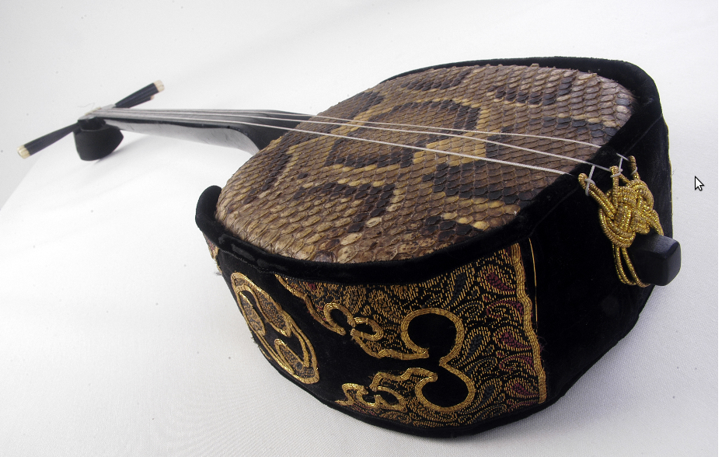

Fig. 12. Okinawan musical instrument sanshin ([三線](http://ja.wikipedia.org/wiki/%E4%B8%89%E7%B7%9A)).

http://en.wikipedia.org/wiki/Sanshin#mediaviewer/File:Sanshin.png

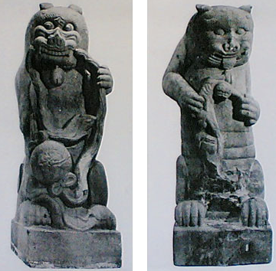

*Shisa* (シーサー), from Okinawa, possibly Edo period, after http://okiken.com/uploads/thumbs/4.jpg

When a Chinese emissary returned from a voyage to the court at Shuri Castle, he brought a gift for the king, a necklace decorated with a figurine of a *shisa*-dog. The king found it charming and wore it underneath his clothes. At the Naha Port bay, the village of Madanbashi was often terrorized by a sea dragon who ate the villagers and destroyed their property.

One day, the king was visiting the village, and one of these attacks happened; all the people ran and hid. The local *noro* (priestess of the Ryukyuan religion) had been told in a dream to instruct the king when he visited to stand on the beach and lift up his figurine towards the dragon; she sent the boy, Chiga, to tell him the message.

He faced the monster with the figurine held high, and immediately a giant roar sounded all through the village, a roar so deep and powerful that it even shook the dragon. A massive boulder then fell from heaven and crushed the dragon's tail. He couldn't move, and eventually died.

This boulder and the dragon's body became covered with plants and surrounded by trees, and can still be seen today. It is the "Gana-mui Woods" near Naha Ohashi bridge. The townspeople built a large stone *shisa* to protect it from the dragon's spirit and other threats (Sesoko 1973).

Bronze mirrors were introduced into Japan from China and Korea during the Yayoi period (about 300 BCE - 300 CE). At first Japanese mirrors had a religious function and were based on the Han designs regarded as symbols of authority. However, the Japanese soon learned to make their own mirrors using the lost-wax technique, decorating them initially with Chinese and then native Japanese designs.

The adaptation of the Chinese Lion Dance to designs on mirrors during the later Sui and T’ang dynasties was known from its popularity at Xian. During the Nara period (710-794 CE) reports and examples of mirrors brought back to Japan from China via Korea created an awareness of this particular dance and art form. These Five Lion Dance mirrors were generally small (up to three inches in diameter) and produced by the loss wax process. Later, in addition to Chinese designs on mirrors there was a growing use of Japanese designs, such as native plants and animals symbolizing good fortune. From the Kamakura period (1185-1333) a design showing Hôraizan (the Chinese 'Island of Immortality') became popular. Mirrors gradually became more robust with a central boss, often in the shape of a tortoise, which was pierced and a cord.

More new designs and the first handled mirrors appeared in the Muromachi period (1333-1568). During the Edo period (1600-1868), mirrors decorated with lucky symbols or Chinese characters were given at weddings. Mirrors became larger as hairstyles became more ornate: some mirrors in Kabuki theatre dressing-rooms were up to fifty cm. diameter and were placed on stands. The faces of mirrors were highly polished or burnished, with itinerant tinners and polishers specializing in this work. Since the mirror, together with the sword and the jewel, were symbols of Imperial power, mirror-makers were deeply revered and often given honorary titles such as Tenka-Ichi ('First under Heaven').

Thus, the Five Lion Dance spread across China and Korea and Japan and its song and dance practiced by those who wish to extol communal peace and harmony.

REFERENCES

Unless otherwise specified, Pinyin transliteration from the Chinese precedes Wade-Giles transliteration and they are separated by "/".

Azarpay, Guitty. 1981*. Sogdian painting: the pictorial epic in Oriental art. Berkeley*: University of California Press.

Ban, Gu (32-92 CE). 1938. *The history of the former Han dynasty* New York: Waverly. 3v.

# *Book of the Later Han.* 後漢書/卷88. Treatise on the Western Regions. http://zh.wikisource.org/wiki/%E5%BE%8C%E6%BC%A2%E6%9B%B8/%E5%8D%B788

Chizue, Sesoko. 1973. *Legends of Okinawa*. Urasoe, Japan.

Dili Scroll 4, Ānxí guó qiǎn shǐ xiàn shī zi jí tiáo zhī dà jué" hòu hànshū /"安息國遣使獻師子及條枝大爵" 後漢書, 和帝, Scroll 4). D. Eastlake, C. Manros, and E. Raymond, RFC 3092: Etymology of "Foo", The Internet Society, April 1, 2001.

Drower, E. S. 1962. The Mandaeans of Iraq and Iran: **: their cults, customs, magic, legends, and folklore**. Leiden: Brill.

## Hsin T'ang-shu. 2004 Trans. Colin Mackerras. Edited and introduced for the Internet by Daniel C. Waugh. http://depts.washington.edu/silkroad/texts/tangshu/tangshu.html

Xuanzang. 1884 [629]. *Si-Yu-Ki: Buddhist Records of the Western World, by Hiuen Tsiang*. 2 vols. Translated by Samuel Beal. London: Kegan, Paul, Trench, Treubner and Co.

Humbert, Aimée. 1874. *Japan and the Japanese*. London: Richard Bentley, 1874.

Gimm, Martin. 1966. *Das Yueh-fu tsa-lu des Tuan An Chieh. Studien zur Geschichte von Musik, Schauspiel and Tanz in der T'ang-Dynastie*. Wiesbaden: Otto Harrassowitz

Goswamy, B. N. 2002. Celebrating with the Lion Dance. *The Tribune, Spectrum,* Oct. 6. http://www.tribuneindia.com/2002/20021006/spectrum/art.htm

Harich-Schneider, Eta . 1973. *A History of Japanese Music,* London: Oxford University Press.

Hsuang-Tsang. 1884. *Buddhist Records of the Western World*, tr. Samuel Beal. London: Truner and Co., Ltd. 2v.

Irwin, John. 1975. Asokan pillars: a re-assessment of the evidence -- the capitals, *The Burlington Magazine*, 117(871):631-643.

Irwin, John. 1983. The true chronology of Asokan pillars, *Artibus Asiae* 44(4): 247-265.

Levi, Sylvain. 1913. Le Tokharian B, langue du Koutcha, *Journal Asiatique*, 2: 348-349.

Malandra, Geri Hockfield. 1993. *Unfolding a Mandala: The Buddhist Cave Temples at Ellora.*

Monier-Williams, Monier. 1898. A Sanskrit-English dictionary etymologically and philologically arranged with special reference to cognate Indo-European languages, Oxford: Clarendon Press.

Nilakanta Sastri, K. A., ed. 1952. *The Age of the Nandas and Mauryas.* Banares [1952].

Padma, Sree and, Anthony W. Barber. 2008. *Buddhism in the Krishna River Valley of Andhra.* Albany : State University of New York Press.

Percy, E. 1939. *Untersuchungen ueber den Ursprung der johanneischen Theologie. Zugleich ein Beitrage zur Frage nach der Entstehung der Gnostizismus*. Lund: Gleerup.

Picken, Laurence. 1988. *Music from the Tang Court*, v. 4. Cambridge: Cambridge University Press.

Rudolph, Kurt. 1978. *Mandaeism*. Iconography of Religions, XXI. Leyden: Brill.

Ryen, John Olav. 2006. *The tree in the lightworld: a study in the Mandaean vine motif*. Oslo: University of Oslo.

Sesoko, Chizue. 1973. *Legends of Okinawa* [Urasoe, Japan]

Shanxiang, Wu. 1999. *Biography of King Mu - A Legendary Book from Ancient China*. Chinese literature. no. 3, (1999): 143. [Peking, Foreign Languages Press].

Shaikh, Fazlur Rehman. *Chronology of Prophetic Events*. 2001. London: Ta-Ha Publishers.

Sykes, Percy.2003. *A History of Persia*. 3rd edition. London:Routledge Curzon Publishers.

Tuan, An-chieh / 段安節 [Duan, Anjie]. 1977. *Yueh-fu tsa lu* / 樂府雜錄 . Taipei : Tai lian guo feng chu ban she, Minguo 66.



Waley, Arthur . 1941. *Translations from the Chinese*. New York: Alfred A. Knopf.

Waley, Arthur . 1949. *The Life and Times of Po Chü-I, 772-846 A.D.* New York: Macmillan.

Walser, Joseph. 2005. *Nāgārjuna in Context: Mahāyāna Buddhism and Early Indian Culture.* New York: Columbia University Press.

Xing, Bing (932-1010 CE). [1965]. Er ya zhu shu /爾雅注疏 . Taipei Shi : Taiwan Zhonghua shu ju, Minguo 54 .

*Yuefu Miscellany*, http://www.tianyabook.com/gudian/yuefuzalu/index.html), accessed May 17 2012.